TECHNICAL OFFER

for the Assignment to

The Trainer in Development of Policy Reporting Documents

(NDC Tracking)

by
Full name

to

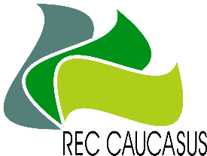
REC-Caucasus

under

the Project

Georgia’s Integrated Transparency Framework for Implementation of the Paris Agreement

Concept of Assignment
Please provide a description of the concept for the assignment in accordance to the tabular format presented below:
Deliverables | Estimated amount of days required | Deadline | Approach
Report on the 1-week on-job training on how to track NDC implementation through the software with presentation
Task: Prepare presentation and training session report on one-week on-job training sessions on how to track NDC implementation through the software to at least 15 central government staff representatives.  This task includes:  - Sharing experience to the training participants on how to develop transparent and accurate progress report on the CAP activities in order to track NDC progress.  - Support marginalised groups and women in active involvement of the training. |  | Click or tap to enter a date.
Total Days of the Assignment |  | Total days of the assignment should not be more than 3 man-days  Daily rate in GEL (Gross)
Duration of the Assignment | from: Click or tap to enter a date.  to: Click or tap to enter a date.

Draft deliverables of the assignment are a subject of agreement with PMU, CCD, and stakeholders (if necessary).
The assignment will be implemented in close collaboration with National mitigation expert, PMU and CCD, including kick off meeting for introductory discussion and regular meetings on consideration of deliverables including JF meetings.

