TECHNICAL OFFER

for the Assignment to

Expert in Policy Documents Development

by
Full name

to

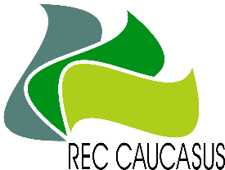
REC-Caucasus

under

the Project

Georgia’s Integrated Transparency Framework for Implementation of the Paris Agreement

Concept of Assignment
Please provide a description of the approach for the implementation of the task in accordance to the tabular format presented below:
Deliverables | Estimated amount of days required | Deadline | Approach
Report on recommendations (in the form of MS Word track changes and suggestions via comments in pre-shared Sustainable Energy and Climate Action Plans (SECAPs)) about considering the requirements of Decree #264 of the Government of Georgia.
Task: Develop recommendations (in the form of MS Word track changes and suggestions via comments in pre-shared SECAPs) about considering the requirements of Decree #264 of the Government of Georgia. |  | Click or tap to enter a date.
Total Days of the Assignment |  | Total days of the assignment should not be more than 4 man-days  Daily rate in USD (Gross)
Duration of the Assignment | from: Click or tap to enter a date.  to: Click or tap to enter a date.

Draft deliverables of the assignment are a subject of agreement with PMU, CCD, and stakeholders (if necessary).
The assignment will be implemented in close collaboration with National mitigation expert, PMU and CCD, including kick off meeting for introductory discussion and regular meetings on consideration of deliverables including JF meetings.

